August 23, 2024

Morning Session by Aditya kansana,

Key Takeaways to follow:

1. Develop Skills and make sure you’re best in it

(Make goal oriented skills)

1. Support and collab with each other
2. Celebrate and appreciate every effort
3. Maintain decorum and respect for each other
4. Take initiatives
5. Be Proactive
6. Build strong and genuine connections

--------------------------------------------------------------------------------------------------------------------------------------

Logic Building by Vipul Tembulwar

Class and Object

OOPs – Object Oriented Programming

Java is not 100% OOP language

Bottom to top execution approach

Class is a collection objects

It’s a blueprint

Will have Its own properties and behaviours

Property – data members

Behaviours – methods

Method Syntax in java

<Access-Specifiers><non-access specifiers><return type> nameOfMethod() {}

Objects are user defined datatype

Object syntax:

ClassName ObjectName = new ClassName();

New is a keyword which is used to allocate memory to object

In java we have

Local Variable

Global Variable

Instance Variable

Static Variable

In instance variable of object, if we not initialise them, they will get default value.

Default value is given as soon as object is created.

Objects are stored in heap are of JVM.

Constructors:

Constructors are used to initialise the instance variables.

Constructors are methods without return type

When there is no constructor defined, default constructor is called.

Default constructor would not be available when we define on our own.

Constructor types:

1. Default
2. Zero
3. Parameterized

We cannot access memory in java

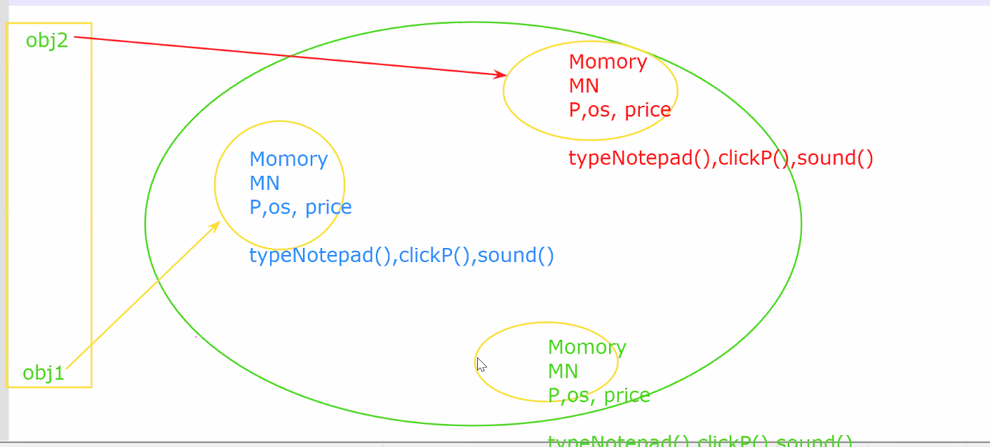

Static methods and variables are same for all objects.

It has a fixed memory

When a static variable updated, it’ll get updated for all instances.

Static variables can accessed in instance methods as well as static methods

Instance variables cannot be accessed in static methods.

//can static variables accessed in constructor?

//Read about overloading

--------------------------------------------------------------------------------------------------------------------------------------

Labs